Random Sample
1,2 | Suppose a random variable X follows the normal distribution with mean 3 and variance 2. We draw a random sample of 50 points from this distribution:  - What do you understand by drawing a random sample? _________________________________________  _________________________________________________________________________________________________________  _________________________________________________________________________________________________________  _________________________________________________________________________________________________________  - If you draw another sample, will it be identical to the first sample? Why or why not? ___________________________________________________________________________________________________________ ___________________________________________________________________________________________________________  _________________________________________________________________________________________________________
Histograms
1 | 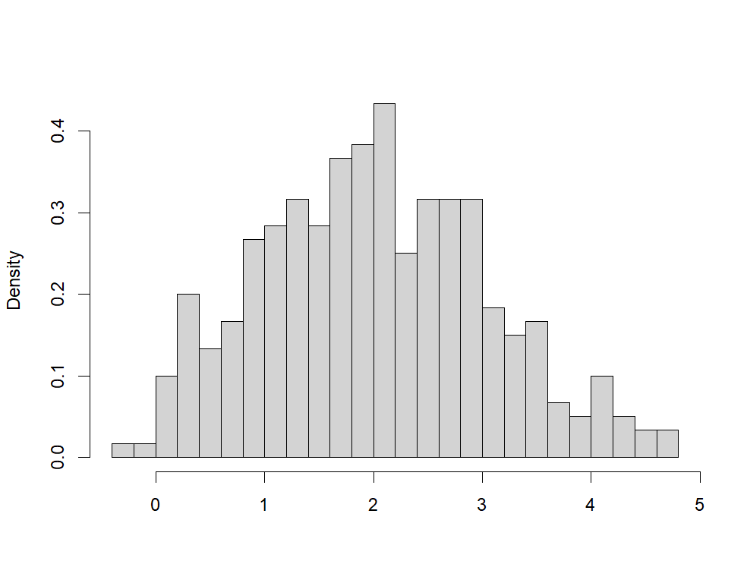  The histogram of a random sample of size 300 drawn from the Normal distribution with mean 2 and standard deviation 1 is depicted here along with the R code used to generate it.  n=300  x=rnorm(n=n, mean=2,sd=1)  hist(x, probability = TRUE, breaks=20)  - Select the correct alternative:  This histogram represents which of the following?  - distribution of the sample b) Sampling distribution
2* | Select the correct alternative:  Consider a histogram where the bin width is 5 units, and the bar for the interval 10−15 has a height of 6. What does the height of the bar represent?  - There are exactly 6 data points between 10 and 15.  - The value of each data point is 6.  - The mean of the data points is 6.  - There are 6 intervals in the histogram.
3* | Select the correct alternative:  You are analyzing two histograms of test scores for two different classes. Both histograms have the same mean, but one histogram has a wider spread. What does this imply?  - The class with the wider spread has a larger sample size.  - The test scores in both classes are identically distributed.  - The two classes have the same average test score but different levels of variability.  - The class with the wider spread has less variability in test scores.
4 | 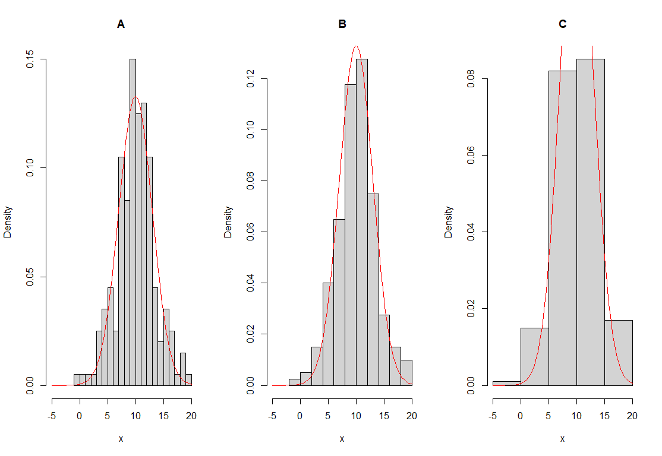  The image above shows three histograms generated from the same dataset. Based on the above figure, answer the following questions:  - What is the key difference between the three histograms?  ___________________________________________________________________________________________________  _____________________________________________________________________________________________________  - Which histogram provides the most detailed view of the data's distribution?  ___________________________________________________________________________________________________  - What problem arises when using very few bins, as seen in histogram C?  ___________________________________________________________________________________________________  _____________________________________________________________________________________________________  - True or False: Increasing the number of bins always makes the histogram clearer. Justify your answer: _____________________________________________________________________
5 | Answer the following questions based on the following image.  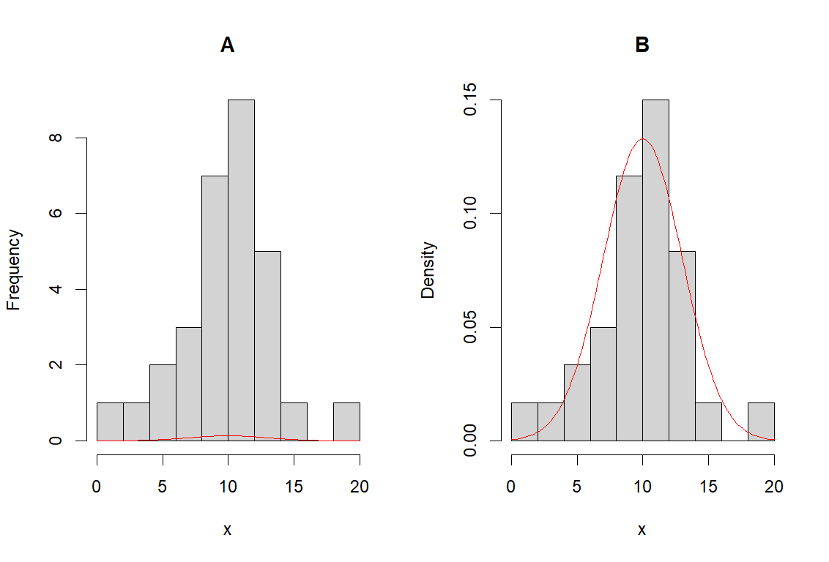  - Choose the correct alternative in the second column corresponding to the code given in the first column below.  - What is the key difference between Histogram A and Histogram B?  _______________________________________________________________________________________________  - True or false: The red curve in histogram B represents a normal distribution fit to the data. Justify your answer. ___________________________________________________________________  __________________________________________________________________________________________________________
  Code | Choose from the following:
  n=30  x=rnorm(n=n,mean=10,sd=3)  hist(x,breaks=10)  curve(dnorm(x,mean=10,sd=3), add=TRUE, col="red”) | - Histogram A  - Histogram B
  n=30  x=rnorm(n=n,mean=10,sd=3)  hist(x,breaks=10,probability = TRUE)  curve(dnorm(x,mean=10,sd=3), add=TRUE, col="red") | - Histogram A  - Histogram B
Sample Statistic
1 | Suppose X follows Poisson($λ$) with $λ$ unknown. We want to estimate $λ$ using a random sample $X_{1}, X_{2}, …X_{50}$. Which of the following is a valid sample statistic to estimate$λ$. Give reasons for your answers.  i ) $\sum_{i=1}^{50}{X_{i}} /50$ Valid: Yes/No Reason: ____________________________________________________  ii) $\frac{(\sum_{i=1}^{50}{\frac{X_{i}}{50}}+λ)}{2}$ Valid: Yes/No Reason: ____________________________________________________  iii) ${\sqrt{λ}}^{2}$ Valid: Yes/No Reason: ____________________________________________________  iv) $\sum_{i=1}^{49}{X_{i}} /49$ Valid: Yes/No Reason: ____________________________________________________  v) ${\sum_{i=1}^{50}{{(X}_{i }- \overline{X}})}^{2}$ Valid: Yes/No Reason: ____________________________________________________
2 | True or false:  A sample statistic, such as the sample mean or sample standard deviation, is used to estimate a population parameter. ___________________________________________________________________________________
3 | Select the correct alternative: A random sample${ x}_{1},x_{2}, ⋯, x_{n}$ of size n = 30 is taken from a population of size $n = 300$. We define $s=\sqrt{s_{n}^{2}}$where $s_{n}^{2}= \frac{\sum_{i=1}^{n}{{\left(x_{i}-\overline{x_{n}}\right)}^{2}}}{n-1}$ . Which statement is generally correct?  - $μ$ is an estimate of $\overline{x_{n}}$; $σ$ an estimate of $s$.  - $\overline{x_{n}}$is an estimate of $μ$; $s$ is an estimate of $σ$.  - $μ$ is an estimate of $\overline{x_{n}}$; $s$ is an estimate of the standard deviation of the sample mean.  - $\overline{x_{n}}$ is an estimate of $μ$; $s$ is an estimate of the standard deviation of the sample mean.  - $\overline{x_{n}}$ is an estimate of $μ$; $s$ is the standard error of the sample mean.
Sampling distribution
1 | What is the difference between a sampling distribution and a distribution of a sample?  _____________________________________________________________________________________________________________  ______________________________________________________________________________________________________________
2 | Explain what the R code in the given box will simulate:  n=30  rep=1000  mean_vals=numeric(length=rep)  for (i in 1:rep){  x=rexp(n=n,rate=2)  mean_vals[i]= 1/mean(x)  }  hist(mean_vals, probability=TRUE)  _____________________________________________________________________  _____________________________________________________________________  _____________________________________________________________________  _____________________________________________________________________  _____________________________________________________________________
3* | State true or false for each of the following questions. If false, explain why or correct it.  For each of the questions, $\overline{X_{n}}$ represents the sample mean for a sample of size n drawn from a population with mean $μ$.
  i | In general, the sampling distribution of the sample mean and the distribution of the parent population have exactly the same shape._______________________________________________
4* | State true or false for each of the following questions. If false, explain why or correct it.  For each of the questions, $\overline{X_{n}}$ represents the sample mean for a sample of size n drawn from a population with mean $μ$.
  i) The distribution of $\overline{X_{n}}$ will have a mean equal to $μ$.
  ii) The distribution of $\overline{X_{n}}$ will have a variance equal to the population variance.
5* | Select the correct alternative: An opinion poll for elections has decided to increase the size of its random sample of voters from 1500 people to 4000 people to estimate the proportion of voters favouring a particular candidate. The effect of this increase is to:  - reduce the bias of the estimate.  - increase the standard error of the estimate.  - reduce the variability of the estimate.  - increase the confidence interval width for the parameter.  - have no effect since the population size is the same.
6 | 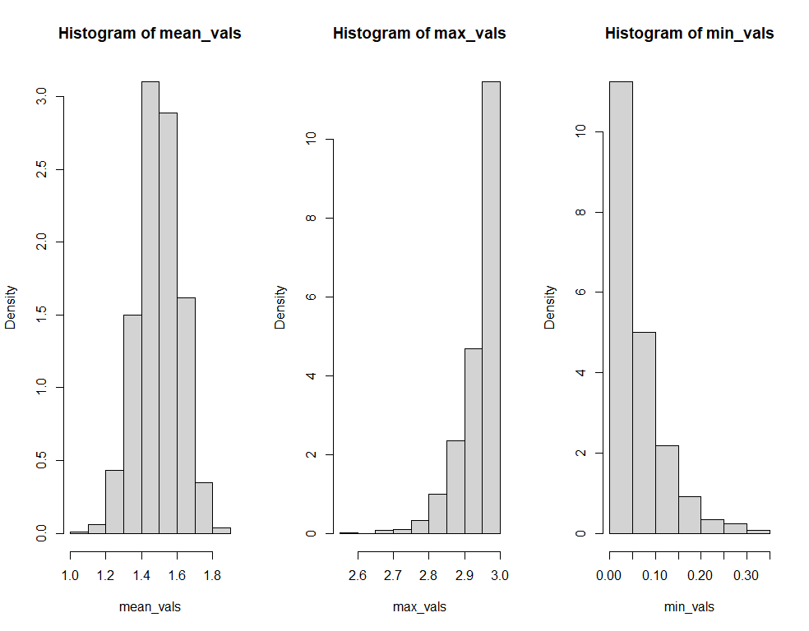  Suppose that $X_{1},X_{2}, ⋯,X_{n} \sim Unif(0, θ)$ with $θ$ unknown. The sampling distributions of the sample mean $\overline{X_{n}}$, $X_{(n)}=max⁡\{X_{1},X_{2}, ⋯,X_{n}\}$ and $X_{(1)}=min⁡\{X_{1},X_{2}, ⋯,X_{n}\}$ respectively are plotted in the histograms above.  i)From the histogram, can you say which of the three estimators is a good estimate to estimate$θ$? Justify your answer. You can use the evidences provided by the histograms to support your choice.
Central Limit Theorem
1* | Select the correct alternative: The Central Limit Theorem states that:  - if n is large then the distribution of the sample can be approximated closely by a normal curve  - if n is large, and if the population is normal, then the variance of the sample mean must be small.  - if n is large, then the sampling distribution of the sample mean can be approximated closely by a normal curve provided the population has finite variance  - if n is large, and if the population is normal, then the sampling distribution of the sample mean can be approximated closely by a normal curve only if the population has finite variance.
2* | Select the correct alternative: The central limit theorem tells us that the sampling distribution of sample means is approximately normal. Which of the following conditions are necessary for the approximations to be valid?  - The sample size has to be large. b) We have to be sampling from a normal population.  c) The population has to have finite variance. d) Population variance has to be small  e) Both a and c
3* | Select the correct alternative:  Consider simple random sampling from a normal distribution with mean 18 and variance 36. For samples of size 9, the sampling distribution for the sample mean has mean and variance equal to:  - 2 and 12 respectively b) 18 and 4 respectively c) 18 and 12 respectively  d) 2 and 4 respectively e) none of these
4 | The plot generated by the R code below can be seen on the right.  n = 100 # sample size  M = 1000 # number of replications  sample_means = numeric(length = M)  for(i in 1:M){  x = rexp(n, rate = 1)  sample_means[i] = mean(x)  }  hist(sample_means, probability = TRUE, main = "Histogram of sample means", xlab = expression(bar(X[n])), cex.lab = 1.3, cex.main = 1.3, breaks = 30)  curve(dnorm(x, mean = 1, sd = 1/sqrt(n)), add = TRUE, col = "red", lwd = 2)  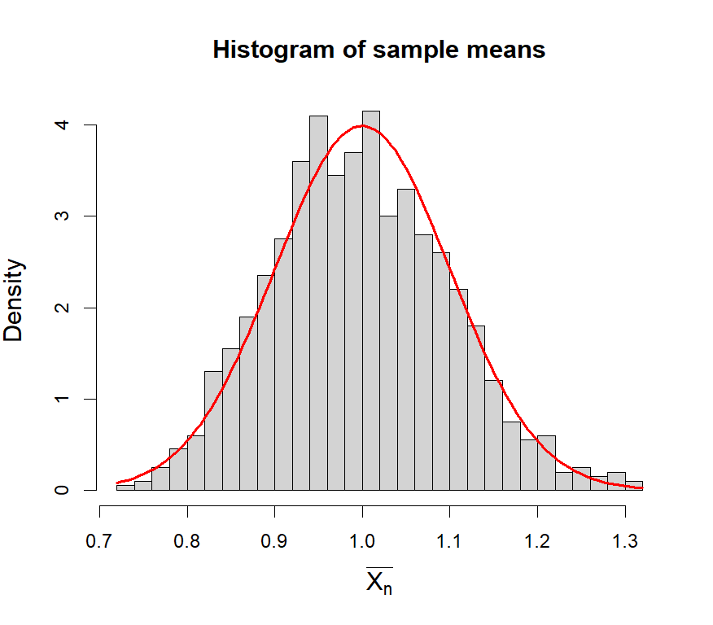  Select the correct alternative: What concept does this simulation illustrate?  - Unbiasedness of the sample mean as an estimator of the population mean  - Central Limit Theorem (CLT)  - Consistency of the sample mean as an estimator of the population mean  - The sampling distribution of the sample mean  - None of the above  (Both response options (b) and (d) were accepted as correct)
5 | 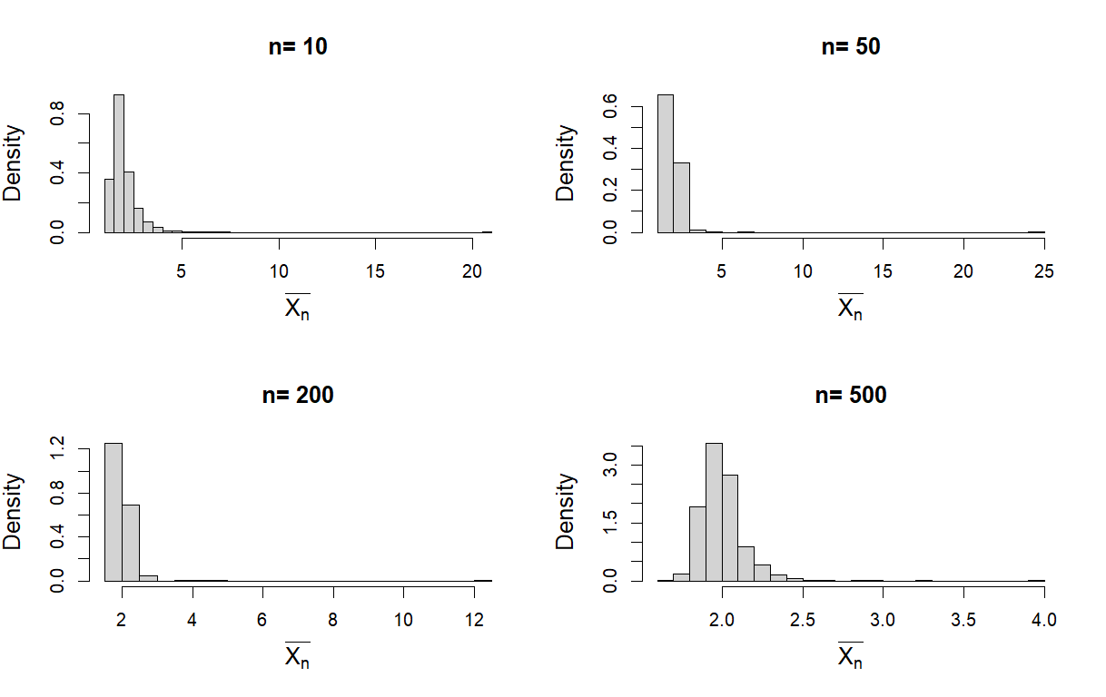  Choose the correct alternative: The sampling distribution of the sample means for different sample sizes from the Pareto distribution with parameters α = 2; t =1 is plotted below. Even as the sample size increases, the sampling distribution of the sample means doesnot seem to approach normality. Does this violate the Central Limit theorem?  - Yes, it violates the CLT because the sampling distribution does not become normal.  - No, it does not violate the Central Limit Theorem because the theorem applies only when the population has finite variance, which is not the case for the Pareto distribution with  α = 2; t =1  - No, it does not violate the Central Limit Theorem because as the sample size will increase further normality will emerge.  - None of the above
6 | Suppose that $X_{1},X_{2}, ⋯,X_{n} \sim Unif(0, θ)$ with $θ$ unknown. The sampling distributions of the sample mean $\overline{X_{n}}$, $X_{(n)}=max⁡\{X_{1},X_{2}, ⋯,X_{n}\}$ and $X_{(1)}=min⁡\{X_{1},X_{2}, ⋯,X_{n}\}$ respectively are plotted in the histograms above.  The sampling distributions of $X_{(n)}$ and $X_{(1)}$ do not seem to follow the normal distribution. Does this violate the Central limit theorem?
Properties of estimators
1 | 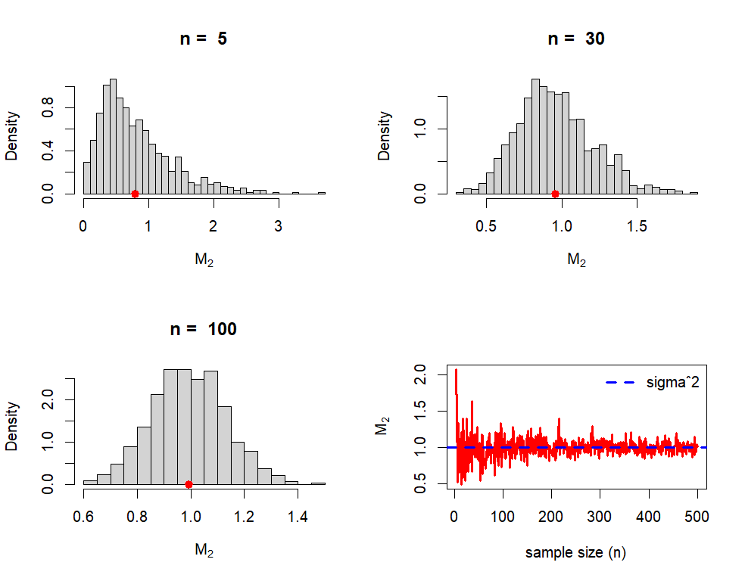  A  B  D  C  We draw samples of size $n$ from a normally distributed population with mean 3 and variance 1. The statistic $M_{2}=\sum_{i=1}^{n}{\frac{{\left(X_{i}- \overline{X_{n}}\right)}^{2}}{n}}$ has been used to estimate the population variance. The histograms shown above depict the sampling distribution of $M_{2}$for different sample sizes. The dot in the histograms A, B and C depicts the mean of the $M_{2}$values obtained in all replications.  In graph D, values of $M_{2}$ obtained through random sampling are plotted for different sample sizes. The blue line marks the population variance.  As per your observations based on the above figure, answer the following questions  - Is $M_{2}$ a consistent estimator of the population variance? Provide reasoning for your answer.  - Is $M_{2}$ an unbiased estimator of the population variance? Provide reasoning for your answer.
2 | Suppose you are conducting a study where you take a random sample of 50 observations from a population with an unknown mean. In your understanding, what does it mean for the sample mean to be an unbiased estimator of the population mean?
3* | Select the correct alternative: The sample mean is an unbiased estimator for the population mean. This means:  - The sample mean always equals the population mean.  - The average sample mean, over all possible samples, equals the population mean.  - The sample mean is always very close to the population mean.  - The sample mean will only vary a little from the population mean.  - The sample mean has a normal distribution.

Note: Questions in the original questionnaire have been renumbered for ease of reference. Only the subset of the items in this questionnaire were analysed for the purpose of this manuscript. The questions used from ARTIST have been marked with (*), the other items have been framed by the authors.

